Dear Exhibitors,

Thank you for your interest in China International Auto Products Expo (CIAPE) !

Involved in the world’s largest auto market, it is a practical question how enterprises can
possess the global perspective and participate in the domestic and international division of labor and competition. Here we highly recommend China International Auto Products Expo, through which I hope you will find the answer.

Characteristics of CIAPE

● The exclusive national platform for international and professional display of auto products in China
● China’s self-independent trade platform for auto products coving the entire auto industry
● Targeted to domestic and international OE market and aftermarket
● Concurrent activities such as high end summits, analysis of policies and regulations, release of new technologies, match making meetings and suppliers conferences, etc
● Trade visitors from all over the world and all sectors
● The first expo at National Exhibition and Conference Center (Shanghai）

Objective of CIAPE

China International Auto Products Expo (CIAPE), based on the China International Auto Parts Expo, is an international and professional platform built by the Chinese government. Its goal is to independently satisfy the growing demand of the domestic and international OE market and aftermarket so that China lives up to the reputation of the large auto maker and auto market. The expo is a bridge for export as well as a platform for innovation exchange. It displays the products and technology of China’s huge OE market and aftermarket as well as the advanced technology and management and business model from across the world. Through communication and cooperation, it will create more opportunities. It is a booster for improving the overall level of China’s auto industry and for the standardized development of the auto aftermarket.

Contents of the expo and exhibits

Whole Vehicle Section with China's independent brands
With the largest auto market in the world, China needs to proactively seek sustainable growth to fulfill its dream of becoming an auto power.
The market demand brought about by China’s rapid economic growth has provided forceful support for making the auto industry stronger in China. Companies possess famous brands and competitive products, own key core technologies and have gained certain market share across the world. Meanwhile, the auto power owns an entire supplying chain that masters the core technology relying mainly on the local enterprises.

New energy vehicle, passenger car, commercial vehicle, micro car, special vehicle,

Auto Parts Section
Technological innovation and strengthened products competiveness in the OE market and aftermarket will help meet the increasingly high expectations of the modern society for automobile,

the high-tech products, in the aspects of energy-saving, emission reduction, safety, environmental protection, comfort, economy etc.
OE market
Enterprises are encouraged to display new technologies, new products and to invigorate and complement the original equipment supplier market，secondary and third OE market. Chinese companies are urged to accelerate the structural adjustment, to optimize and integrate international and domestic resources. They are encouraged to strengthen the cooperation between auto and auto parts enterprises and to accelerate the modularized and systematic supplying capability. Chinese enterprises will further participate in international division of labor and promote the formation of a group of world class auto parts suppliers.

Aftermarket
With the auto market entering the micro growth era, excellent sale and after sale model will lead a revolution in the entire aftermarket.
CIAPE is fortunate to have the support of the Ministry of Commerce of the People's Republic of China, Department of Circulation Industry Development. Based on large-scale quality suppliers, distributors and service providers in the aftermarket, CIAPE along with the eight aftermarket unions, namely unions of domestic wearing parts, auto parts from Europe, America, Japan and Korea, commercial vehicle parts, micro car parts and maintenance and testing equipment, will promote the standardization of the market order, perfect the credit system, allocate resources rationally and promote full competition. We will create brands, serve end customers, grow electronic commerce, and implement traceability system for auto parts quality, etc. The purpose is to build the system and the model that are suitable for the development of China’s OE market so as to benefit suppliers, distributors as well as customers.

Engine system, chassis system, body system, electronic system, general parts and materials
(OE parts, brand parts, AM parts, remanufactured parts)

Electronics and Information Technology Section
Electronics and Information Technology Section aims to adapt to technological and industrial revolutions characterized by the new internet and new energy technologies. The section showcases the research and industry strength of electronics and information technology on which the car networking technology relies, and the integration and application level of the electronic information technologies and traditional technology. Our goal is to enhance the technological value, market value and service value of electronics and information technology products.

Promotion of information technology of public transportation and commercial vehicles, auto navigation and positioning products, auto electronics, demonstration of innovations of smart transportation, new energy vehicles and electric vehicles

Clean Fuels Section
Clean Fuels can greatly reduce the environmental footprint by cutting auto energy consumption and emission of pollutants in vehicle exhausts. Therefore clean fuels for vehicles are favored by countries around the world. As relevant technologies and equipment improve, many fuels have been put into
commercial use. In China, governments and enterprises attach great importance to replacing traditional energy with clean fuel.
Methanol fuel, Ethanol fuel, biofuel, fuel cell etc

Technical Equipment Section
“Sharp tools make good work.” The level of the auto manufacturing industry is reflected by that of the equipment manufacturing industry. Technical Equipment Section will showcase top technical equipment from home and abroad for the auto and auto parts manufacturing companies. It will boost the upgrading of manufacturing equipment and help the auto and component manufacturers keep abreast of the latest development of the manufacturing industry.

Mould and metal manufacturing equipment, automation technical equipment, plastic and rubber and packaging equipment, foundry equipment

Auto Accessories Section
China’s auto accessories market is on the path of steady growth.
Innovation of products, electronic commerce, intensification and standardization are the inevitable trends for the auto accessories market in the competition.
CIAPE is an international platform for Chinese auto accessories companies to participate in global
trading. The organizer will invite numerous domestic and overseas buyers to the expo which will create multiple opportunities for the exhibitors to broaden their horizon and to establish trade channels home and abroad. It will also be the first time for the auto accessories manufacturers in the Yangtze River Delta to meet with domestic and overseas purchasers.

Auto beauty care products, auto communication and navigation, auto video & audio entertainment, auto electronic appliances, auto tuning products, auto interior & exterior products, auto safety products, auto energy saving products, auto environment friendly products, auto outdoor products

Auto Maintenance and Diagnosis Equipment Section
Auto Maintenance and Diagnosis Equipment section serves vehicle safety performance testing, comprehensive performance testing, whole vehicle maintenance enterprises, maintenance stations for specific problems, chain auto maintenance enterprises and fine equipment of auto vocational schools. Through the expo, the initiative of industry associations and enterprises will be brought into play and technical conditions of establishing an auto maintenance enterprise will be implemented. It is also our goal that the enterprises reputation will be assessed, the qualification of practitioners will be recognized and the establishment of the training system will be built. CIAPE will help improve the management level, technology level and service level of companies. The expo will also boost the implementation of the Inspect/Maintenance (I/M) system, advocate modern maintenance models such as “Green Maintenance” and “Technical Maintenance”. We will improve the I/M technique and equipment and advance the professional and standardized transformation, upgrading and sustainable growth of the whole industry.

Auto Inspect/Maintenance and diagnosis equipment, measurement tools, microcomputer system, related equipment etc, auto maintenance equipment, special repair tools, spray paint, lifting, body repair, calibration equipment etc, green auto repair equipment and materials, auto repair instruction
equipment and facilities

Tire Section
Professional purchasers will be invited from over 100 countries and regions such as the United States, Germany, India, Italy, Korea, Thailand, Singapore and Taiwan, etc. The expo provides tire

enterprises opportunities of meetings global quality buyers, promotion of their brand images, development of their business channels etc. The purpose is to advance the transformation and upgrading, structural adjustment, technical innovation especially the research and development of ‘Green Tire’. By doing so, we hope to gradually eliminate the major issues in the industry such as product homogeneity and structural over-capacity, to promote the healthy growth of the tire industry and to provide opportunities for China’s tire enterprises towards marketization and internationalization.

Auto tires (passenger cars, commercial vehicles, tuning cars, engineering vehicles), auto wheel hub, wheel rim, tire and related parts

Auto Tuning Section
As car ownership increases and people’s living standard improves in China, the need for auto personalization is expanding. Auto Tuning Section will help consumers better understand auto tuning and help them build a safe, modern, green, environment friendly auto tuning concept. Besides domestic auto tuning works, technology and products, CIAPE will also showcase organizations,
brands, products, technologies and concept of the countries that are advanced in auto tuning such as America, Germany, Japan etc. The expo will also promote the international auto tuning and management experience and accelerate the standardization, marketization, industrialization of China’s auto tuning. It will explore China’s auto stock market and expand the domestic demand and at the same time fulfill people’s increasing need for personalization, which will also contribute to fostering the non-governmental innovation.

Modified vehicle, engine system, cooling system, air products, exhaust parts, electronic appliance, drive system, suspension system, brake system, body and chassis, wheel rim, tire, chemical oil, appearance package, interior parts, audio & video, wear goodsa, tuning boutique

Motorcycle Section
“EICMA CHINA—The Motorcycle Show” is an international, professional and market-oriented motorcycle exposition approved by the Ministry of Commerce, People’s Republic of China. The expo has been held successfully for four years, displaying the overall capability and development level of China’s motorcycle industry. It provides a platform for display, trade, exchange and cooperation for both Chinese and international motorcycle，electric vehicles and motorcycle parts enterprises.
Working with China Chamber Commerce of Motorcycle (CCCM) and Eicma Spa, Motorcycle Section displays the achievements of China’s motorcycle industry of the past 30 years as well as the image of promoting China’s own brands based on technology progress. Renowned overseas companies and buyers will be invited to the expo to facilitate the cooperation between domestic and overseas companies in electric vehicles, high-end high-emission motorcycles, scooters, key parts, famous motorcycle products etc. It will play an active role in elevating the integrated level, boosting the transformation and upgrading and in achieving the leapfrog growth of China’s motorcycle industry.

Motorcycle, electric vehicle, all terrain vehicle, moped, motorcycle engine and other parts, motorcycle clothing and equipment, motorcycle manufacturing and maintenance equipment

Intellectual Property Rights Protection

Strengthening Intellectual Property Rights(IPR) protection is a certain claim for spurring innovation and for promoting the transformation of the growth model of China’s economy. It is urgent for China to promote its opening-up and to accelerate its structural adjustment. Unswervingly carrying out the

national IPR strategy, CIAPE strives to create a legal, market and cultural environment for IPR protection. IPR protection and traceability institutions will be established by governmental agencies at CIAPE.

High level concurrent activities

Professional activities such as International Auto Parts Summit Forum will be held during the expo at which popular issues of the global auto industry and development trend will be discussed. Various seminars, negotiations, training and dialogues on state-of-the-art technology and innovation, global procurement, communication and aftermarket will be held, which will provide broad and profound value-added services to the exhibitors and purchasers.

Review
About CIAPE
CIAPE is the exclusive state-level international, professional and market-oriented expo in the auto industry. The expo has been held successfully for 7 years, attracting 7,193 exhibiting companies from 40 countries and regions as well as over 230,000 professional trade visitors and purchasers from more than 100 countries and regions.

CIAPE has won the support and cooperation from various parties such as 39 automotive societies from 17 countries and regions in China, Germany, the US, UK, France, Italy, Japan, South Korea, Spain, Canada, Australia, Italy, India, Iran, Pakistan, the Philippines, China Taiwan etc, 9 famous multinational automobile groups like GM, Toyota, Volkswagen etc, the world’s top 4 auto parts corporations such as Bosch, Denso, Delphi etc, 20 major domestic automobile groups like SAIC, FAW, Dongfeng, Chang’an etc as well as the 12 national auto and auto parts export bases.

As a national platform, CIAPE receives attention from various parties. Mr. Zhang Dejiang, former member of the Political Bureau of the CPC Central Committee, Vice Premier of the State Council, and officials from Ministry of Industry and Information Technology and Ministry of Commerce all visited the expo many times for inspection and guidance.

Well-known Exhibitors at CIAPE
International: Bosch, Denso, Continental, Aisin, ADVICS, Delphi, Borg Warner, Toyota Boshoku, Hyundai Mobis, Hyundai Kia, Hyundai Dymos, Pirelli, Goodyear, NGK, Hitachi, Asimco, Tenneco, Johnson Controls, GETRAG, Dow Corning, Shell, Lear Corporation (Beijing) Limited Co., Ltd., Alpine Electronics, Pioneer, Kenwood Electronics etc.

Chinese: Wanxiang Group Company, Weichai Power, Huayu Automotive Systems Co., Ltd., Dongfeng Automobile Parts, Yuchai Group, Fawer Automotive Parts Limited Company, Shaanxi Fast Auto Drive Group Co.,Ltd., Wanfeng Auto Holding Group, SG Automotive Group Co.,Ltd.，Zhejiang Asia-Pacific Mechanical and Electronic Co.,Ltd., Zhejiang Yinlun Machinery Co., Ltd., Changchun
FAW Sihuan Group Co., Ltd., Tri-Ring Group Corp, Qingte Group, Qijiang Gear Transmission Co.,

Ltd., Fuyao Group, Xinyi Group, Binzhou Piston, Shandong Gold Phoenix Group Co.,Ltd., Asimco Shuanghuan Piston Ring Co., Ltd. (Yizheng), Ta Tung Gear, GSP Automotive Group Wenzhou Co., Ltd., Beijing Hainachuan Automotive Parts Co., Ltd., Shijiazhuang Jingang Internal Combustion
Engine Parts Group Limited, Beijing West Industry Co., Ltd., Zhengxing Wheel Group Co., Ltd., Changhui (Shanghai) Science & Technology Group Co., Ltd., OED Engine Co. Ltd., Zomax Group
Co., Ltd., Zhejiang Luoshi Vibration Control Co., Ltd., Jiangyin Mould Plastic Group, Chongqing Yujiang Casting Limited, VIE Group, Ruili Group, Xiangyang Bearings, Zhuzhou Torch Spark Plug Co., Ltd., Wuhan Chutian Industry Laser Equipment Co., Ltd.

Whole Vehicle Manufacturers: GM, Toyota, BMW, FAW Group Corporation, Shanghai Automotive Industry Corporation (Group), Chang'an Automobile (Group), Beijing Automotive Industry Holding Co., Ltd., China National Heavy Duty Truck Group Co., Ltd., Great Wall Motor Company Limited, Chery, Geely, Anhui Jianghuai Automobile Co., Ltd., ZOTYE, Jiangling Motors Co., Ltd., Zhengzhou Yutong Group Co., Ltd., Higer, Xiamen Golden Dragon Bus Co., Ltd., Youngman Automobile Group Co., Ltd., Zhongtong Bus Holding Co., Ltd. etc.

Analysis Report
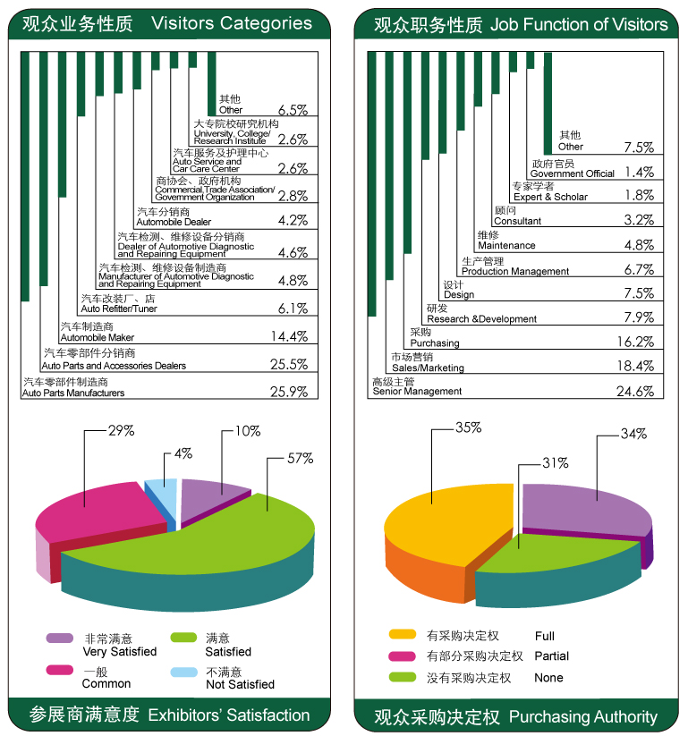

About the Venue
The National Exhibition and Conference Centre (Shanghai) is currently the world's largest exhibition complex, composed of the exhibition center, the supporting commercial center, the office building and hotels. Located
in the Shanghai Hongqiao Central Business District, the center enjoys 8 means of transportation provided by

the Hongqiao transportation hub such as Metro Line 2, the high-speed railway, the airport etc. It serves as an excellent platform for auto enterprises to use Shanghai as a hub and expand presence in China as well as in the world

Expo Info
Dates: October 19 to 21, 2014
Frequency: Annual
Floorage: 100,000 sq. m.
Visitors (Estimate): 50,000
Application Deadline: Aug. 31, 2014
Venue: National Exhibition and Conference Center (Shanghai）
Stand Setting-up: Oct.15 to 18, 2014
Exhibition: Oct. 19 to 20, 2014 (9:00-17:00)
Oct. 21 2014 (9:00-16:00)
Stand Dismantling: Oct.21, 2014 (16:00 – 21:00)

Stand Rate
Shell Scheme: 2180 RMB/ m² (3m*3m)
A surplus 10% is charged for corner stand.
Space Only: 1980RMB/m² (Min.: 36 m²)

Payment Details
Beneficiary: Genertec International AE Co., Ltd.
Add: 12/F, West Wing of Sichuan Mansion, 1 Fuchengmenwai Avenue,Xicheng District, Beijing 100037, P.R. China
Deposit Bank: Bank of China, Head Office, Banking Dept.
Add: 1 Fuxingmen Nei Dajie, Beijing 100818, P.R. China
Account No.: 778350035077
Swift Code: BKCHCNBJ

For more information, please visit www.iapechina.com
or scan the QR code


Contact the Organizing Committee
通用国际广告展览公司
中国国际汽车商品交易会组委会
Phone： 86-10-68991436/1432/1961
Fax： 86-10-68991422/1830/1414
Contacts： Mrs. Zhang Yazhu, Mr. Xie Yufeng, Ms. Lu Yihan
E-mail： info@iapechina.com / xieyf518@yahoo.com / nicole@iapechina.com
Add: 12F., West Wing of Sichuan Mansion, #1, Fuwaidajie St., Beijing, China 100037
地址：北京市西城区阜外大街1号四川大厦西塔楼1203A，100037
Website: www.iapechina.com

